Product Name: Simple controller Model: CW-S01

PWM Generator Module
- SKU: 815871

This controller, the original function is unchanged, increased can generate PWM signal function. There is a jump pin on the board. You can set options, the default is set in the generation of pulse frequency signal.
REQ is to generate a pulse frequency signal.
PWM generates PWM signals

Dimensions:
Length * width * height: about 73*51*37MM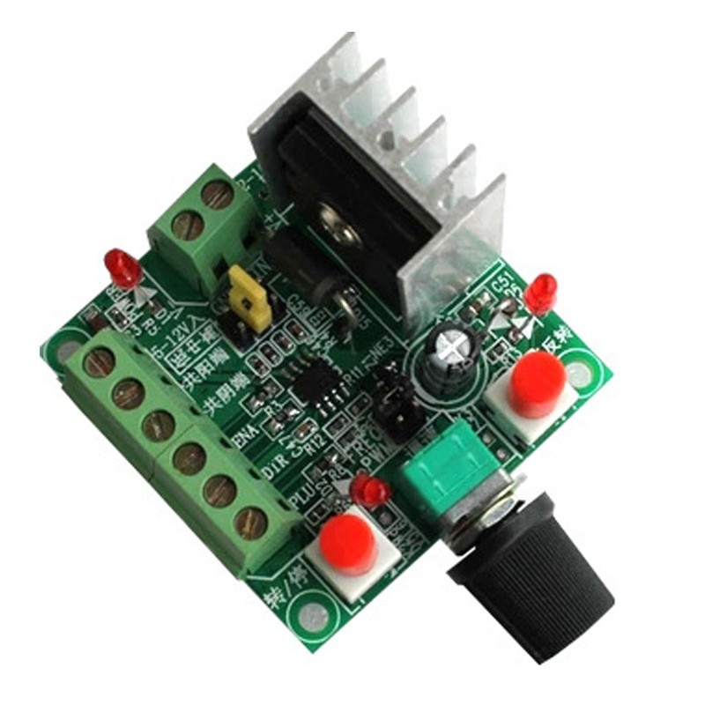
I. Product description:
1. When the controller generates pulse frequency signal, it can supply stepping driver as signal. If you want to control the stepper motor, it must be equipped with a driver.
This simple controller + stepper driver + stepper motor + DC power supply can form a set of simple control platform.
2. the controller can generate pulse frequency signal, can also generate PWM pulse width signal. There is a jump pin on the board, you can set options, the default is set in the generation of pulse frequency signal.
REQ is to generate a pulse frequency signal
PWM generates PWM signals
3. When the controller generates pulse frequency signals, there are three kinds of frequency signals, namely high, medium and low, which can be selected by the jump pin. The frequency parameters are approximately:
High: 5.8KHZ-127KHZ
Medium: 590 Hz-15.8 KHZ
Low: 82HZ-2.3KHZ,
Frequency measurement: can measure PUL and common negative end (GND) two ports.
4. The power supply has 2 groups of power input, 2 groups only connected to a group of power supply. It is recommended to use a power supply of more than 15V. Connect the two terminals to the power supply. Do not connect the positive and negative terminals inversely.
One group is connected to DC 15-160VDC power supply, recommended working voltage 15-80VDC.
The other group is 5-12VDC. When it is used with a driver, it is recommended that the minimum power supply be 12V. Do not use a 5V power supply. When the 5V power supply is not very good, the power supply is connected to the "5-12V inlet" and the power supply is connected to the "common negative terminal".
.
5. Dimensions: Length * width * height: about 73*51*37MM

II. Wiring instructions:

1. There are silk-screen instructions beside the terminals of each connection port. It can be connected to a stepper motor driver with a common negative or positive connection.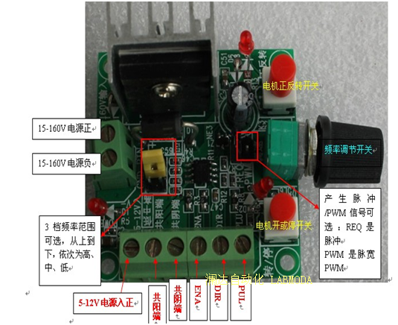

PUL: pulse port
DIR: indicates the direction port
ENA: enables port
Common negative terminal: common terminal common ground (GND)
Common positive terminal: common terminal (+5V)
5-12V power input: The positive end of the 12V power supply is usually empty. You are advised to use a power supply of more than 15V.

For Example: common positive connection with the driver, if it is the driver of 6 signal lines, the +5V common end of 3 signals should be combined into a line to all receive the common positive end
controller | driver
PUL | Pulse negative end (PUL-)
DIR | Direction negative (DIR-)
ENA | Enable negative terminal (EN-)
Common positive end | Common terminal (COM or +5V or PUL+DIR+EN+ at the same time)

Note:
1. If the on/off function is to be used, the ENA enabler on the controller must be connected to the drive in either negative or positive mode.
2. The positive and negative rotation of the motor as well as the start and stop of the motor can be controlled by pressing the button.
3, the speed of the motor can be controlled by adjusting the potentiometer to change the frequency.
4. The original switch of positive and negative rotation and opening and stopping of the motor is an ordinary switch with self-locking.
======================================================

